HE PŪRONGO – AUTUMN 2020

Tēnei te mihi ki a koutou katoa. Nau mai, haere mai, whakatau mai.

Warmest greetings to our members and supporters throughout Aotearoa and Australia. This edition of ‘He Purongo’ features news about our:

- CEO Welcome to 2020.
- What’s Going On? Hannah, Max and Dara.
- KMA Recipe #2 – “Kai o te Tai Tongo”.
- Panui Accessibility.
- Staff Movements – Welcome Ngatamaine.
- 2020 Summer/Autumn Events.

It’s now 2020 and we want to share more stories about the achievements of our members and supporters. If you would like to know more or wish to share your story, please get in touch by phoning 0800 770 990 or by emailing your stories to delayne.tutemahurangi@kapomaori.com.

Summer greetings to our members and supporters in Aotearoa, Australia and the South Pacific to this, our first panui of the year.

The KMA operations and field whānau have increased since our last panui, starting with the birth of Hannah and Nick’s son Max prior to Christmas 2019. Hannah also received a new guide dog named Dara and in February we welcomed our newest staff member, Ngatamaine. Both Hannah and Ngatamaine are featured in this edition and we hope you enjoy reading their stories.

An exciting initiative is the launching of our ‘members’ only page’ on our website. This will include a pictorial history of events dating back to the 1990’s. Prior to going live, KMA Tangata members will be issued with a personalised access code. We have also fine-tuned how ‘new’ members and supporters can register online or to make a financial contribution to our kaupapa. Please monitor our Facebook Page, website or phone our 0800 freephone number for progress updates.

We hope you enjoy this edition of ‘He Pūrongo’ and look forward to receiving your stories and your feedback.

Ngā mihi nui,
Chrissie and KMA team.

What’s Going On? – Hannah, Max and Dara.

Tangata whai kaha kaimahi Hannah has been busy this past year. She has written an update to let us know what she’s been up to.

Kia Ora koutou, toku whānau o Kāpō Māori Aotearoa. Ngā mihimihi pai. Happy 2020, I hope you all have had a great Christmas, new year and summer break.
For our whānau down here in the south – what a year. A year ago, I was battling away as a Paralympic hopeful but now, a year later, I’m a proud mum to our sweet baby boy.

On 4 December 2019, Nick and I, along with our whanau, welcomed Max Everard Crawford into this world. It has been a few crazy months learning how to care for a new-born baby. He is so beautiful, growing astronomically fast and gives many ‘Max snuggles’. Every day is different and challenging, but it’s all worth it when seeing the changes, he makes and milestones he meets.
What we have learnt is that even though I am a Kāpō mummy, the challenges are no different to any other new parent, we’ve had to learn his cries, working out when he’s tired, hungry and ready to bring up wind. You learn to appreciate sleep and breaks, when you manage to have one. I’m so thankful for Nick and our wider whānau for the support. We are very blessed to have each other and our whānau.
If life wasn’t busy enough with Max, we still have the day to day running of a household, the endless loads of washing, house renovations, and now a new wee guide dog.
Photo 1: Hannah, Nick and baby Max.

A totally unexpected but enormous surprise was to be matched with a bubbly energetic girl named Dara who, co-incidentally, was a puppy raised by the same friends who adopted Cora. So naturally, since she has spent a lot of time with Cora, Dara has some of her traits and is just a fantastic guide! It’s been awesome being able to just get out walking again with such freedom! What makes it that even cooler is when we have Max in the baby carrier and we all can hit the street together.
And after all that, I still have time to keep up with my training. After Max’s 5.30am feed, I have breakfast then I’m on my bike, before the day begins all over again. I am looking forward to returning to work later in the year and being able to catch up with you all! So, in the meantime, take care and remember from the most unlikely parents, anything is possible.
Photo 2: Hannah, baby Max in his carrier and Dara.

Hannah, Nick, Max and Dara.

‘Kai o te Tai Tongo’ Recipe #1 – Crispy Tītī on Bruschetta with Watercress Aioli: Kasey and Karena Te Awa-Bird

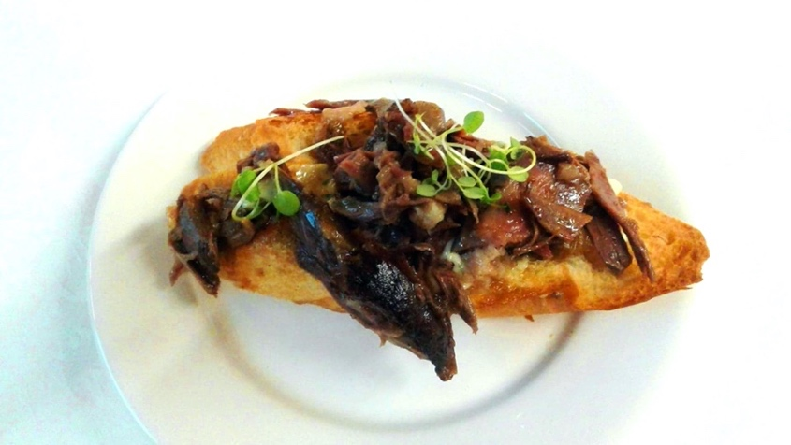
Kasey and Karena’s first conference with Kāpō Māori Aotearoa was in Invercargill, 2017. With fresh kai from the south, Kasey and Karena made three more wonderful recipes to share – this editions recipe has tītī or muttonbird, served on toasted bruschetta with a watercress aioli.
Photo 3: Crispy Tītī on Bruschetta with Watercress Aioli.

Crispy Tītī on Bruschetta with Watercress Aioli – (serves 4)

Tītī Bruschetta:

500 grams | Tītī
1 | Baguette
garnish | Baby Watercress

Watercress Aioli:

1 cup | Watercress leaves, (remove stalks), or Baby Watercress
1 clove | Garlic
1/3 cup | Mayonnaise
¼ | Lemon

Directions:
- For Tītī:
  - Place tītī into a large pot and cover with water.
  - Bring to the boil, reduce heat and continue to boil for 45 minutes. (Taste water and if it is still very salty, drain and add fresh water and boil for a further 30 minutes) Cook until meat is tender and pulls away from the bone.
  - Remove tītī from the pot and pat dry.
  - Cut tītī into bite sized chunks and grill until crispy.
- For Aioli:
  - Finely chop watercress leaves and garlic.
  - Mix ingredients with mayonnaise and lemon juice.
- To Serve:
  - Slice Baguette into 12 generous slices and toast.
  - Smear aioli on the slices and top with crispy tītī chunks.
  - Garnish with baby watercress and serve.

Send your photos or reviews of your Crispy Tītī and Watercress Aioli to our Facebook page, https://www.facebook.com/KapoMaoriAotearoaNZ.

PANUI ACCESSIBLITY

Previous Panui have been uploaded to our website for you to download. An audio version of our Summer 2019 Panui is also available to download. This season’s panui will be available for download, both audio and written versions, on our website, https://www.kapomaori.com/news/newsletters/

KMA STAFF MOVEMENTS

As of February 2020, Kāpō Māori Aotearoa welcomes Ngatamaine Tauranga to the operations team. Ngatamaine joins us as our new Media Assistant, bring administrative support in our panui and various social media platforms. Ngatamaine wrote a special piece to introduce herself to you all.

Kia Orana, my name is Ngatamaine Tauranga and I am of Cook Islander Māori descent. I have family in Aitutaki and Mangaia in the Cook Islands and in Hastings, New Zealand, where I was born.

I have cerebral palsy which limits my movement and I cannot communicate verbally. This, however, doesn’t limit me and I am very independent. I get around in a motorised wheelchair and I speak through my computer. I have completed several courses at Eastern Institute of Technology, (EIT), Quality Education and The Career Academy. I have volunteered in various fields for the past 19 years and I currently sit on two national Pasikia boards for Pasikia people with disability. I sometimes feel frustrated because people pre judge me and think I am not independent but there is nothing I can’t do.

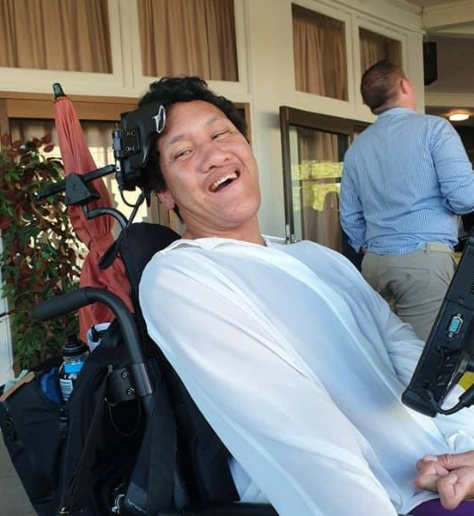
I went to the Kāpō Māori Aotearoa Biennial conference in Napier in 2019. I loved the Biennial conference; it was different to other conferences I had been to previously. It was very interesting to see how this conference was conducted for blind and deaf people, especially for Māori. I am now working for Kāpō Māori Aotearoa as a Media Assistant and I will be helping with Kāpō Māori Aotearoa’s panui, Facebook and website. I would like to learn how to maintain the Kāpō Māori Aotearoa website. I would also like to learn more about the blind and deaf communities.
Photo 4: Ngatamaine Tauranga.

Ngatamaine, (Nga).

Event Updates
- February – March 2020 – Auckland Arts Festival, check their website for more information about their accessible art exhibitions and shows.
- February 2020 – The Access Alliance People's Choice Accessibility Awards for Business, with CEO as a co-host.
- March 2020 – KMA staff meets with the CEO of Blind and Low Vision New Zealand, John Mulka and his regional managers.

Mā te kimi ka kite, mā te kite ka mōhio, mā te mōhio ka mārama
Seek and discover. Discover and know. Know and become enlightened.

Te Kahui Tumuaki me ngā Kaimahi o Kāpō Māori Aotearoa.

Contact:
0800 770 990
(toll free)
or
www.kapomaori.com
Autumn Edition 2020

