He Pūrongo – Autumn 2017 Edition
Nau Mai, Haere Mai!

In this panui:
- Update from the Executive Officer
- Projects we’re working on, and
- Staff and Event updates.

CEO CHAT …
Tēnā tātou katoa

Welcome to the Autumn 2017 edition of our panui ‘He Pūrongo’. As you will read, Te Kahui Tumuaki and staff have been busy progressing our 2016/2017 priorities.

Te Kahui Tumuaki continue to play an active role in monitoring and advocating on your behalf about national initiatives that affect kāpō Māori whānau within the Kāpō community and also the Tangata whai kaha Māori whānau community generally. Key initiatives that the Board provided advice and guidance on were the review of Whāia Te Ao Mārama, the Māori Disability Action plan review and the drafting of the New Zealand Disability Strategy.

Board members and myself continue to represent Kāpō Māori Aotearoa on a number of committees and reference groups including the Blind Sector Forum Aotearoa New Zealand, a collective of national blind consumer organizations and the Blind Foundation. The forum meets four times a year to discuss issues that affect the lives of blind, vision impaired and deaf blind people and collectively agree on solution’s-focussed approaches towards reducing barriers faced by our respective members.

In February 2017 the Board accepted the invitation of the Blind Foundation to register as a member of the Alliance for Accessibility for New Zealanders Act. The Alliance is a coalition of national Disabled Persons Organisations and Non Government Organisations campaigning for legislation that will set national standards for accessibility across all areas of New Zealand life and the economy.

A new initiative announced in March 2017 by the Minister for Disability Issues that Te Kahui Tumuaki are monitoring and providing advice is the co-design process for a nationwide transformation of the disability support system. The transformation is based upon the Enabling Good Lives (EGL) vision and principles. EGL is a principles-based approach that empowers disabled people with self-directed planning, some members may have been involved in demonstrations facilitated in Waikato and Christchurch. The transformation will initially focus on those disabled people receiving support from Disability Support Services, Ministry of Health in the Mid-Central region (around Palmerston North). The intent of the transformation is to provide better support and better services for disabled people and their families.
Also in March 2017 the Board received confirmation that our Waitangi Tribunal Claim 2109 had been officially entered on to the Wai 2575 Health Services and Outcomes Inquiry and that a judicial inquiry will be held 11th and 12th May 2017 at which our submission will be presented to the Inquiry Panel. Members who wish to attend this hui are welcome. More information about venue and times is provided in the Wai Claim 2109 section of this panui.
A highlight for Te Kahui Tumuaki was hosting the Global Network of Indigenous Peoples with Disabilities meeting in Wellington 13th to 15th March 2017. Representatives from First Peoples Disability Network of Australia, First Peoples of Turtle Island (Canada), Kāpō Māori Aotearoa and Tangata Whai Kaha Māori Whānau National Leadership Network came together to share lived experiences, celebrate our respective cultural identities and develop collective priorities and an action plan to guide the further development and growth of the network.
A key focus of Te Kahui Tumuaki during 2017 is the progression of our Governance Sustainability strategy. Activities include hosting wananga for members who are interested in learning more about the role and responsibilities of the Board, connecting with members and preparing for Biennial Conference and the General Meeting, at which three of the current board members will retire.
Operationally, we have had staff changes with the departure of Te Awhina Tibble who moved on in January 2017 to pursue a career as an Occupational Therapist and the appointments of Delayne Tutemahurangi in March 2017 and Janene Tihema in April 2017. Delayne lives in Auckland and joins our field team and Janene lives in Hastings and will be part of our administration team. Also in February 2017 we amended the job title of our field workers from National Field Consultant to Tangata whai kaha kaimahi (Hapori Māori) – Māori Community Disability Field Worker. The new title provides better clarity about the role of our field workers.
During January to April staff implemented a national telephone members’ catch up, assisted kāpō Māori and their whānau to engage and navigate Blind Foundation vision services and local community services and commenced planning activities that will be implemented during 2017.
Highlights have been the launch our ‘Kāpō Kete’ a product line of harakeke kete for white canes and providing additional options by which members can contact and communicate with us, these including our public Facebook Page, group texting and set up of the Kāpō Māori Aotearoa TIS line.
Key focuses for operations for the remainder of 2017 are maintaining regular contact with our members, promoting our ‘Kāpō Kete’ products, promoting the ‘Three kete of Knowledge’ Tangata membership Investment structure, completing our annual kāpō whānau member feedback survey, growing the Tangata whai kaha Maori whānau national leadership network membership, developing initiatives that enable members to meet collectively, designing rangatahi development workshops and last but not least preparing for and co-ordinating Biennial Conference 2017.
I would like to take this opportunity to encourage you to let us know if there is an activity you believe other members may be interested in doing, providing us with feedback about our current activities and to phone our 0800 freephone or send a comment through our Facebook page or website or text us 027 599 9081. We would love to know what you and your whānau are doing. One last thing to help us to keep in contact with you, if you have changed your mobile phone or landline phone numbers, postal or email addresses please let us know.
Ngā mihi ki a tātou katoa
Chrissie Cowan
TE KAHUI TUMUAKI TIMES …
At the September General Meeting 2017 three board members will be retiring in accordance with the remit passed at the 2015 General Meeting. We extend our appreciation to all of the retiring Boards members, acknowledging the support, guidance and mahi they have provided during their terms.

Those who wish to are encouraged to pursue nomination for voting at the General Meeting. To find out more contact Adele Vukula on 0800 770 990 or adele.vukula@kapomaori.com

SPOTLIGHT ON …
Staff, Delayne Tutemahurangi,
Tangata Whai Kaha Kaimahi (Hapori Māori)
(Māori community disability field worker)

How did you get involved with Kāpō Māori Aotearoa?
I was told about Kāpō Māori Aotearoa in 2016, by family members who are members. I have Keratoconus, and from age 12, I was misdiagnosed, kept on waiting lists, forgotten, judged and not directed to the appropriate agencies for support. After 11 years of jumping through the wrong hoops and talking to the wrong people, my frustrated family urged that I join Kāpō Māori Aotearoa. It has been one of the most enjoyable journeys I have been on thus far. I am now more independent, have a greater sense of self and have the incentive to share the growth Kāpō Māori Aotearoa has inspired in me to new and existing members.

What was your first impression of Kāpō Māori Aotearoa?
They understand; to have someone there to listen and unload all the frustrations of dealing with your condition lifts the bottled up burdens that many of us Kāpō keep. It is an added and refreshing bonus to talk to people who know where you are coming from and understand the problems you face.

What might someone be surprised to know about you?
I competed in science fairs when I was younger and have won awards for my research in grey water; such as the New Zealand Statistics - Excellence in Scientific Research award, four NIWA awards including the MAF Excellence in Investigation in Environmental Sciences Award, A scholarship to the Liggins Institute where I studied the effects on the application of grey water, and was later awarded the Silver CREST Award for my study.

DID YOU KNOW … We have a TIS Line
As a result of members’ feedback surveys, we will be setting up a Telephone Information Service (TIS) Line through the Blind Foundation. Kāpō Māori Aotearoa NZ will be Option 55. This service is only available from landlines, to find out what your regional number is, contact Adele Vukula on 0800 770 990.

BIENNIAL CONFERENCE 2017
Kāpō Māori Aotearoa NZ will host the Biennial Conference on Saturday 9 and Sunday 10 September at the Ascott Park Hotel, Invercargill. Lots of mahi goes in to planning an exciting event for our members to come together and manaaki one another. The theme of the conference is ‘Water and Light’, and the program will include interactive workshops, an off-site visit to Te Rau Aroha Marae, mana whenua presentation, key note speaker, and the General Meeting. There will also be opportunities to enjoy the unique delicacies of the rohe and of course Southern hospitality.

Register Now
Registrations are now open. You will need to complete a registration form for each person attending. If you would like to secure your place please contact Adele and book in now. There are limited spaces available so you don’t want to miss your chance to sample Southland’s finest fare. The last day to register is 11th August 2017.

Registration Costs
Registration costs are per person and include accommodation, kai, workshops and activities as listed below:

Tangata Member Rates  3 nights $375.00  2 nights $350.00  1 night $175.00  Daily rate $50.00 | Non-Tangata Member Rates  3 nights $400.00  2 nights $410.00  1 night $205.00  Daily rate $80.00

Childrens’ Rates
When attending with an adult attending the conference
0 – 12 years $10.00 per day
13 – 17 years $15.00 per day

In the past we have heard of whānau raising funds to pay for their registration, through applying to local iwi or community funders who may sponsor your attendance. Other whānau have fundraised by running raffles, selling kai or hikoi (X$ per km). You can begin paying your conference registration at any time, either weekly, fortnightly, or one lump sum. Contact Adele to get bank account details. Full payment of Biennial Conference fees is due by 25 August 2017.

Travelling
If you know you are attending please begin preparation for your journey down south now. There are often cheap fares to Dunedin, Queenstown or Christchurch and even Invercargill itself. We are happy to talk through potential options with you to ensure a safe and smooth trip.

There will be further panui in the months ahead. Connect with us on Facebook to keep updated or contact Adele on 0800 770 990 or adele.vukula@kapomaori.com

TANGATA (FINANCIAL) MEMBERSHIP
The annual financial membership subscription is $20.00. We have developed a new initiative that gives you the choice of how you wish your subscription to be invested. The initiative is based upon the kaupapa of our logo, in particular the ‘Three Kete of Knowledge’. Investing in any one or all of the three kete will ensure the ongoing support Kāpō Māori Aotearoa provides for its members.

The Three Kete of Knowledge Initiatives include:
- The Kete of Mind (Hinengaro)
- The Kete of Body (Tinana) and
- The Kete of Soul (Wairua).

To find out more or register as a new Tangata member or renew your membership, contact Adele on 0800 770 990 or email adele.vukula@kapomaori.com

GOVERNANCE SUSTAINABILITY PROJECT
A Governance Training Wānanga will be held on Saturday 6 May 2017 in Wellington. This wānanga is an opportunity for members who are interested in learning more about being a member of Te Kahui Tumuaki, the National Executive board.

HAVE YOUR SAY … by participating in our Whānau Feedback Survey!
Once a year we undertake a national whānau survey to assess the performance of Kāpō Māori Aotearoa in supporting our members:

- What did we do?
- How well did we do it?
- What we need to improve?

We will be making contact with our Kāpō Māori Aotearoa Whānau during May 2017. You may have contributed in previous years and we appreciate that, but would you like to provide some more feedback? You can do so by completing the online survey by using this link: https://www.surveymonkey.com/r/DIAS2017

WAI CLAIM 2109
In March we received confirmation from the Waitangi Tribunal that our claim had been officially entered on to the Wai 2575 Health Services and Outcomes Inquiry.

A follow-up panui has been received from the Tribunal advising that a judicial conference of the Wai 2575 Health Services and Outcomes Inquiry will be held 11th May (12 noon to 5.00 pm) and 12th May 2017 (9.00 am to 1.00 pm) at Pipitea Marae, 55-59 Thorndon Key, Wellington. Kāpō Māori Aotearoa Board members, Executive Officer and lead claimant Maaka Tibble will be attending to support our submission. Members are also welcome to attend. We would appreciate if you could contact Adele Vukula on 0800 770 990 or adele.vukula@kapomaori.com to confirm your attendance so that we can advise the Tribunal.
INTRODUCING … Kāpō Kete
Do you struggle on where to put your white cane when not in use? Introducing the answer, Kāpō Kete.

These Harakeke-woven kete are available in three styles and can have up to two colours. They are suitable for various cane lengths and have adjustable straps. Prices are $40 for Natural (any style) or $45 for Dyed (any style) and include postage and handling. Discounted rates available for Tangata Members. To order or find out more, contact Adele on 0800 770 990 or adele.vukula@kapomaori.com

Image 1: Cross-Body, dyed purple with white cane. | 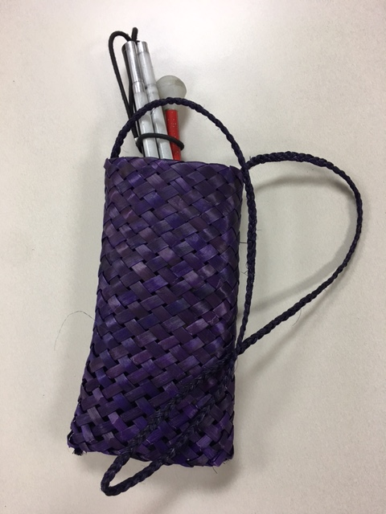
Image 2: Kete, natural colour with white cane. | 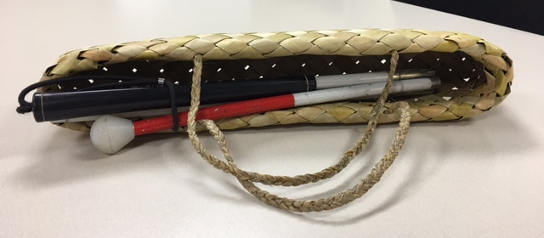
Image 3: Over the shoulder, dyed magenta with white cane. | 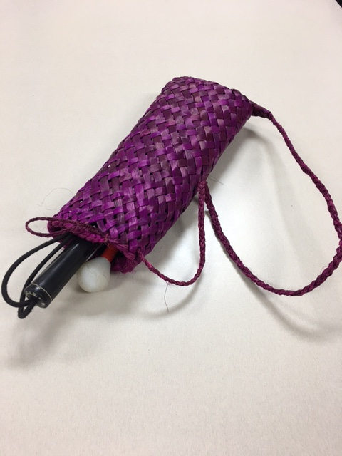

WHAT WE’VE BEEN UP TO…
- Global Network of Indigenous People with Disabilities Meeting
During 13 – 15 March 2017, the Chief Executive Officer, Chrissie Cowan and President, Nigel Ngahiwi hosted delegates from Canada and the First Peoples Disability Network of Australia and Tangata Whai Kaha Māori Whānau National Leadership Network; at a three-day conference held at the Copthorne Hotel, Oriental Bay, Wellington.
- Tangata Whai Kaha Māori Whānau National Leadership Network
Do you want to be connected with other like minded Māori disabled and whānau within your local community and nationally? This network can do just that, and keep you updated on events that affect the Tangata Whai Kaha Maori community. Registration is free and can be done simply by completing the online registration form: https://www.surveymonkey.com/r/TWKRegoForm
Call Adele Vukula on 0800 770 990 to find out more.
- Kāpō Māori Aotearoa NZ Facebook page
Over the last few months we have introduced a Facebook page. This page is updated regularly with events, information and updates relevant to our Kāpō Māori Aotearoa whanau. Connect with us to be kept up to date: www.facebook.com/KapoMaoriAotearoaNZ.
- Staff Training
The Kāpō Māori Aotearoa team came together in March and April to plan out the remainder of activities for 2017. There’s a lot going on and we look forward to updating you all about it.
- Website… 2017 Launch
The journey to refreshing the site has been a long one, but we think it is well worth the wait and you’ll like what we have created. The intended ‘go live’ date is 01 June 2017. Keep checking back on www.kapomaori.com

What’s Coming Up
- 6th May – Governance Wānanga, Wellington
- 11th & 12 May – Wai 2575 - Health Services and Outcomes Kaupapa Inquiry, Wellington
- 11th August – Biennial Conference Registrations close
- 25th August – Biennial Conference Fees due

