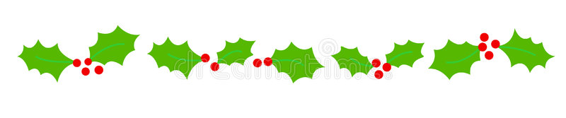
Ngā mihi o te Kirihimete me te Tau Hou

Warmest greetings to our members and supporters throughout Aotearoa and Australia. Our humble apologies for the lack of panui during 2022. To make up for this our Summer 2022 edition of ‘He Purongo’ consists of four complementary panui, the first three titled ‘Reflections’ and, the last titled ‘Looking forward 2023’.

Panui Release Dates

You will receive your copy of each panui on the following dates:

- 16th December 2022: ‘Reflections - October to December 2021’
- 23rd December 2022: ‘Reflections - January to June 2022’
- 30th December 2022: ‘Reflections - July to December 2022’
- 6th January 2023: ‘Looking forward 2023’

All of the panui will be posted on the same dates, on our FaceBook and website. Please feel free to share our panui with your whānau and through your networks.

We take this opportunity to thank you all for your support and contributions during 2022 and we look forward to catching up with you in 2023.

Have safe and relaxing Christmas and New Year.

Chrissie, Lisa, Janene, Tarewa, Ngatamaine and Delayne

- KMA Hui Taumata 2021 “Getting over it (COVID-19) and Getting on with it!”
Having been through two years of COVID-19 restrictions and rescheduling of dates our national biennial hui taumata was held 22nd to 23rd October at the Copthorne Hotel, Oriental Bay, Wellington.
Photo 1: Group Selfie
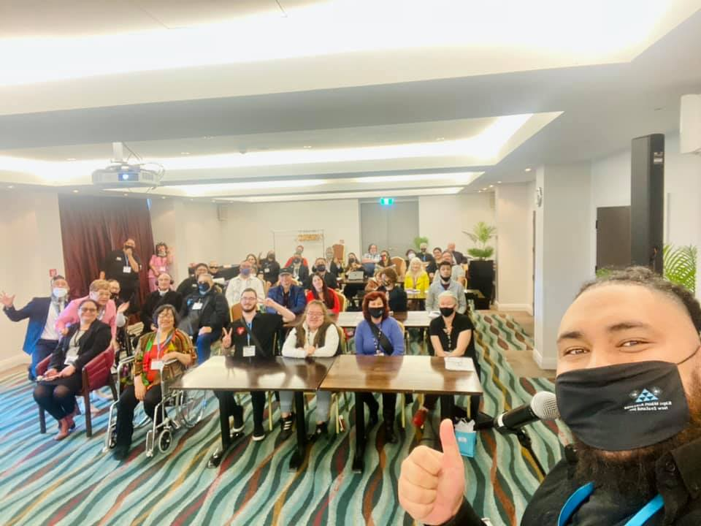
Our conference theme “Getting over it (COVID-19) and Getting on with it!” saw the introduction of capping the number of delegates at sixty and hybrid presentations.

We would like to acknowledge and thank mana whenua representatives Neavin Broughton and Te Ahi ā Tahurangi Kapa Haka, our key note speakers, John Mulka, Blind Low Vision NZ, Dr Bridgette Awatere-Masters and Dr Rebekah Graham, Bill Te Huia Hamilton and Karena and Kasey (via zoom) Bird.

Of course our conference would not have gone so smoothly without our MC Te Kahurangi (TK) Webster, who took back the reins Saturday morning, hours after being at the birth of his son. TK and Trojan, aka ‘T-Sharp’ entertained delegates with musical interludes and was backup for Deone Eketone . ‘Peanut Slab’ a local 5-piece band wowed delegates to a mix of old school, disco, reggae an hip hop music. Delegates were treated to kapa haka performances from Te Kohu a Tawa Kapa Haka, Tawa College and Te Ahi ā Tahurangi,
Photo 2: Te Kohu a Tawa Kapa Haka
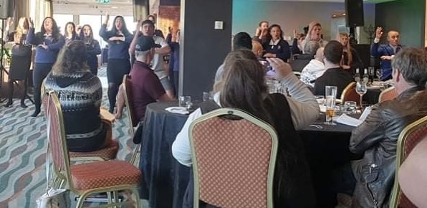

Our sincere thanks and gratitude to Nick, Chetan, Lana, Kenny and the Copthorne Hotel Oriental Bay whānau who made everyone feel welcome and safe.

Special mention to Tamara Nolan, ‘Pure Delight’ for her pop up stall and to her dad Carl, winner of the grand prize gifted by the Copthorne Hotel Oriental Bay of two day accommodation and breakfast for 2 people at any Millennium group hotel in Aotearoa.

Lastly, we would like to acknowledge our sponsors Ministry of Health, Te Pou and Blind, Low Vision New Zealand and contributors Copthorne Hotel Oriental Bay, Ombudsman New Zealand, the University of Waikato, Idlewild Avenue and Audio Workshop.

Kārena & Kasey Bird Hui Taumata Recipes

Green lipped kutai with bacon bone Butter

Recipe
Photo 3: Green lipped kutai with bacon bone butter

(SERVES 20)

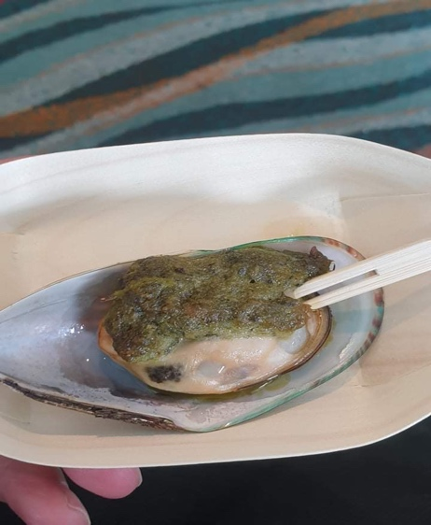
For the bacon butter:

4 bacon bones
2 litres cups water
250 grams watercress
1 lemon
20 mussels Storm clams
200 grams butter

Place bacon bones into a pot and add water. Bring to a boil and simmer for 1 hour. Add watercress and
cook for a further 20 minutes. Drain and pick meat off bacon bones.

Shuck mussels adding liquid to food processor.

Place butter, bacon bone meat, watercress and zest of the lemon into the food processor with the storm clam juice. Mix until well combined.

Place a spoon full of the butter on to each clam and place
under a hot grill for 3-5 minutes. Garnish with fresh watercress and a squeeze of lemon juice.

Prawn brioche with dashi butter sauce

Recipe
Photo 4 Prawn brioche with dashi butter sauce

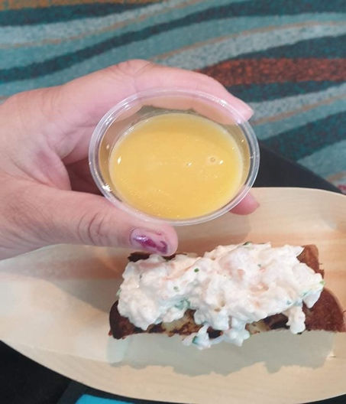
For the dashi:
3 pieces of wakame
2 packets of bonito flakes
1 packet dried mushrooms
1 tbsp soy sauce
500 mls water
300 grams butter

For the prawn mix:
250 gms boiled prawn meat
½ cup kewpie mayo
1 tbsp sriracha
Zest of 1 lemon
Juice half a lemon
¼ cup chives, chopped
1 loaf of brioche
Oil for frying
Chives for garnish

Method:

Place the water, wakame, mushrooms and bonito in to a pot and bring to a boil. Leave to boil for 5 minutes. Turn the heat off and add the bonito flakes. Leave to steep for at least half an hour. Taste, and add soy sauce if needed. Strain and leave the broth to the side until ready to serve.

Once ready to serve, place the strained broth in a pot and bring to a gentle simmer. Whisk in the butter chunk by chunk. Chop up the prawn meat and mix together with all of the ingredients except the brioche.Slice the brioche in to rectangles. Pan fry the bread portions in the vegetable oil till bread feels crispy on each side.

To serve, place the prawn meat on the toasted brioche and garnish with chives. Place the brioche in the bowl and pour ¼ cup of the warm broth in to the bowl.

- KMA 2021 General Meeting

The KMA General Meeting was held on Saturday, 23rd October 2021. Our top three highlights:

- KMA 2021-2023 Te Kahui Tumuaki members confirmed:

- Nigel Ngahiwi: President
- Gaylene Te Rauna: Vice President
- Raewyn Lovich: Executive Member
- Natasha Swann: Executive Member
- Wiremu Kohere: Executive Member

- Joseph Twomey inducted as a KMA Life Member.
- Confirmed that KMA 2023 hui taumata and 40th anniversary will be held in Queenstown.

Photo 5: From Left to right - Caleb Young, Vic West and Joseph Twomey
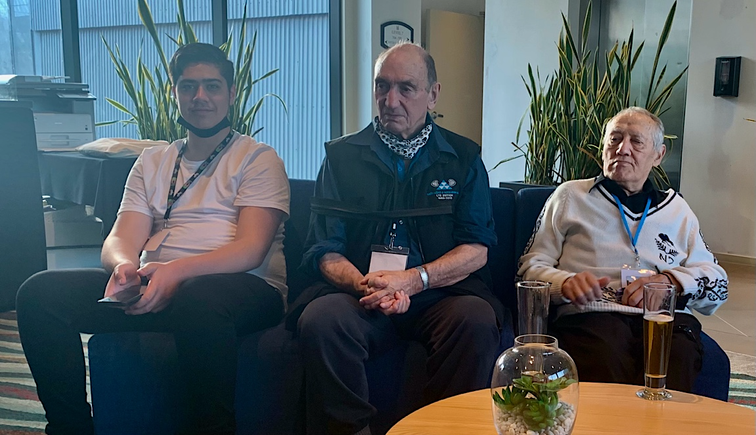

- Whānau Stories
Photo 6 Brandon Edwards
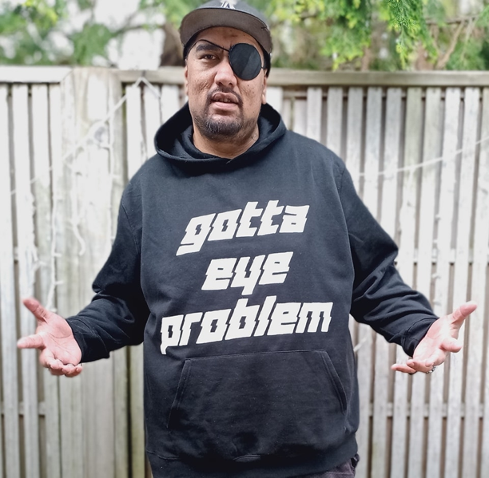
Brandon Edwards

New Member Brandon Edwards from Masterton, turned an uncomfortable situation into a social statement – He is now proudly wearing his homemade ‘gotta eye problem’ hoodies, addressing the awkward stares he received for wearing his eye patch.

Brandon is a great example of turning a negative experience into a positive solution.

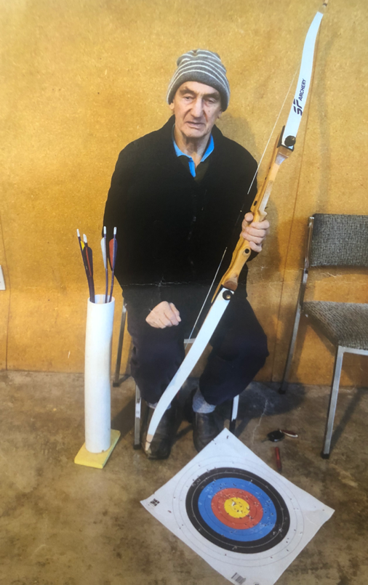
Photo 7: Vic West
Vic West
KMA kaumatua Victor West from Invercargill, shared a photo of his most recent hobby he’s taken a liking to – Archery!

The photo shows Victor holding his bow in one hand with his absolutely destroyed paper target at his feet.

Victor’s aim looks to only be improving if the number of bullseyes are anything to go by!

- About Us

Kāpō Māori Aotearoa (KMA) is the oldest national tāngata kāpō Māori (Māori blind, low vision and deaf blind) and national tāngata whaikaha Māori Disabled People’s Organisation (DPO) in Aotearoa. Set up by kāpō Māori and their whānau in 1983, to provide peer support and advocate for tāngata kāpō and tāngata whaikaha Māori whānau Te Tiriti o Waitangi rights.

We are whānau inclusive and diverse: pan-ethnicity, pan-tribal, pan-age, pan-disability, and provide a dual role, as a kaupapa tāngata whaikaha Māori advocate and as a government contracted Māori health and disability service provider.

Our foundation is Te Tiriti o Waitangi (Māori version), guided by traditional and contemporary Kaupapa Māori values, principles, and practices, and we are a registered Incorporated Society, under the New Zealand Charities Act 2005. We are independent, governed by a board of five, who are elected by our ‘Constitutional Tangata’ members.

We serve tāngata kāpō Māori, tāngata whaikaha Māori and whānau!

- Contact Details

- Phone our free phone: 0800 770 990
- Email us at: info@kapomaori.com (General enquiries)
- Email us at: referrals@kapomaori.com (Support services referrals)
- Facebook: https://www.Facebook.com/KapoMaoriAotearoaNZ
- Website: https://www.Kapomaori.com/

