HE PŪRONGO – WINTER 2020

Tēnei te mihi ki a koutou katoa. Nau mai, haere mai, whakatau mai.

Warmest greetings to our members and supporters throughout Aotearoa and Australia. This edition of ‘He Purongo’ features the following news:

- CEO Update.
- What’s Going On? Catching up with KMA Whānau.
- KMA Recipe: MTK Special – “Joseph’s Lockdown Scones”.
- KMA COVID-19 Updates.
- John Mulka: Chief Executive of Blind and Low Vision NZ.
- KMA Whānau.
- 2020 Winter/Spring Events.

As you will later read in this edition, we want to share more stories about the achievements of our members and supporters. If you would like to know more or wish to share your story, please contact our freephone 0800 770 990 or email your stories to info@kapomaori.com.

Late winter greetings to our members and supporters in Aotearoa, Australia and the South Pacific to our end of season panui. This edition is jam packed with stories that we’re collected over our shared past four months in lockdown.

The KMA operations team and rangatahi group, Te Maanakitanga Kotahitanga, have had the pleasure of being in contact with our KMA whanau; during the nation-wide COVID-19 lockdown we experienced from mid-March to early June. We have had an overwhelmingly positive response from our membership, which you will read about later.

We have a special interview with John Mulka; Chief Executive of Blind and Low Vision New Zealand. John has shared his life, passions and Matariki resolution with us, so make sure you read this exclusive scoop!

We also present a new “KMA Whānau” section, that we hope will be a panui staple for upcoming editions. If you would like to in the next edition, please contact us by email or call our freephone 0800 770 990.

We hope you enjoy this edition of ‘He Pūrongo’ and we look forward to receiving your stories and your feedback.

Ngā mihi nui,
Chrissie and KMA team.

What’s Going On? – Catching up with KMA Whānau.

During the COVID-19 Alert Levels, Kāpō Māori Aotearoa and our rangatahi group Te Maanakitanga Kotahitanga, (M.TK.), had the opportunity to call, text message and email our Kāpō Māori membership throughout Aotearoa. From these calls we were able to reconnect with members and update details, check on those most venerable and help support those members in need.

Over 40,000 forms of contact were made including phone calls, texts, emails and post throughout our whole membership. An additional 38,507 total views were made on our Facebook page that had ongoing information throughout the Alert Levels.

M.T.K had the chance to connect to our rangatahi in Aotearoa and uplifted our community with their many status posts on their Facebook page.

K.M.A did similar endeavours to make sure our membership were well informed during the lockdown. Weekly updates to our Facebook and Website shared not only information and government updates but entertainment – particularly the lockdown music sessions by Trojahn Tuna and Te Kahurangi Webster.

Thank you to those who replied to our text messages and emails, answered our calls and responded to our Facebook and website updates.

If you should have any questions or concerns you can call our freephone 0800 770 990, and if we don’t answer, leave a message and we will get back to you as soon as possible.

KMA Recipe: MTK Special – Lockdown Scone: Joseph Taka

For those who follow Te Maanakitanga Kotahitanga’s Facebook page, you most likely have seen M.T.K member, Joseph Taka’s baking skills. In this edition of He Pūrongo, Joseph shares his recipe for Lockdown Scones, that have already been viewed by over 32,000 people!

Lockdown Scones – (serves 12)
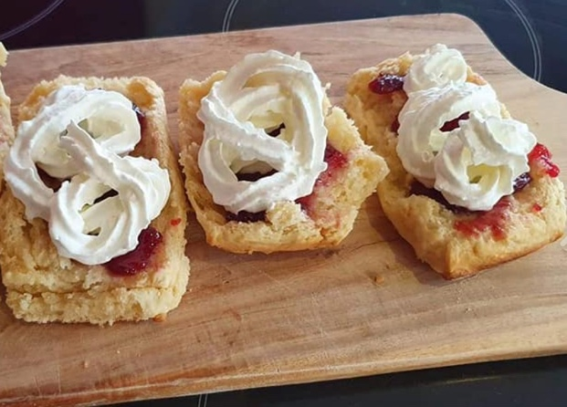
Photo 1: Lockdown Scones
4 Cups | Self-Raising Flour
300ml | Cream (1 small bottle)
¼ Cup  300ml  ½ teaspoon | White Sugar  Lemonade  Salt
Ingredients;

Directions:

- Preheat oven to 220°C and cover an oven tray with baking paper or grease with baking spray.
- Mix all ingredients in a bowl to form a smooth dough
  - The mixture will be quite sloppy
- Tip out dough onto a floured surface and form a round disk.
  - Like a pizza base but not as thin.
- Carefully lift the disk onto baking tray and cut into 12 pieces.
- Bake for about 15 – 20 minutes
  - You may need help with checking, but when they are start to colour pale golden – they’re ready.
- Remove from oven and leave to cool, covered with a tea towel.
- Cut in half and serve with butter, whipped cream and jam.
  - Serve warm.

Joseph has photos of the whole process on M.T.K’s Facebook page. Please send in your photos or reviews of your Lockdown Scones to our Facebook page, https://www.facebook.com/KapoMaoriAotearoaNZ.

KMA Covid 19 Update

Aotearoa is now at Alert Level 1, everyone can return without restriction to work, school, sports and domestic travel, and you can get together with as many people as you want.

It is highly recommended that we stick to our good habits, like washing our hand regularly, staying home if we have a cough or feel unwell and to keep track of your movements when leaving your home.

It is very likely that we may see our current COVID free streak break in the coming weeks, but it is nothing to be overly worried about. We handled cases before, and we can do it again.

Our country, communities and whānau have done an amazing job and now it time to support local and unite for the recovery!

JOHN MULKA: CHIEF EXECUTIVE OF BLIND LOW VISION NEW ZEALAND.

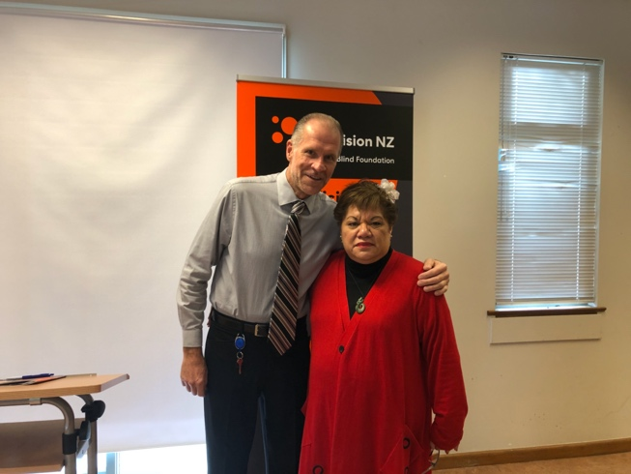
John Mulka is the Chief Executive of Blind Low Vision New Zealand and moved from his homeland, Canada, to start in this role in September 2019. The Kāpō Māori Aotearoa team had the opportunity to ask John some questions about his family and his impressions of Aotearoa, New Zealand. The following are John’s responses.
Photo 2: John Mulka and Chrissie Cowan.

Korihi te manu, takiri mai i te ata
Ka pō, ka ao, ka awatea
Tihei mauriora!
Ki a koe e Papatuanuku te whaea o ngā mea katoa, tēnā koe
E ngā iwi, te tangata whenua, o Aotearoa, tēnā koutou
Ki ngā mema o Kāpō Māori Aotearoa, Niu Tīrani, tēnā tatou katoa
Ehara ahau i te tangata mohio ki te korero otira, e tika ana kia mihi atu kia mihi mai
No reira, tēnā koutou katoa.

Ko Grouse te maunga
Ko te Moana-nui-a-kiwa te moana
Ko Mulka tōku whānau
Ko John tōku ingoa
Ko Lori tōku hoa rangatira
Kotahi tā maua tamaiti, ko Tommy tana ingoa
No Kānata ahau
I whānau ahau ki Edmonton
I mua I taku taenga mai ki Niu Tīrani i te mahi ahau i Vancouver
Kei Tamaki Makaurau ahau e noho ana āianei
Ko au te Kaiwhakahaere matua o Blind Low Vision NZ
Nō reira, tēnā koutou, tēnā koutou, tēnā koutou katoa.

- Tell us a bit about your whānau!

I am an only child of immigrant parents, who as young children moved with their families to Canada for a better life and greater opportunity.

My father is Polish and mother is Ukrainian. Dad was a mechanical engineer and my mother was an accountant. I grew up in a catholic household, with amazing parents who always sacrificed so I could have a roof over my head and food on the table. At the time, I did not realise how lucky I truly was and many of the personalities I possess they instilled in me. Both are now naturally retired and in good health in their late 70s and still live in the same house in Edmonton, Alberta they built when I was 3 years old (that’s 53 years ago). They were scheduled to visit me in New Zealand in March of this year but that was postponed due to Covid-19.

I lived in Edmonton for the first 35 years of my life before moving to Vancouver in the late 90s for a job opportunity and been there since before moving to NZ in September 2019. My wife Lori is a flight attendant in Canada and has been for 30 years. She has chosen to retire from that career to come to NZ and enjoy life in Aotearoa. Her career brought her many times to NZ and although I had never been she reassured me - we would love it - and she was absolutely correct. My son Tommy is 21 years old and established in Vancouver. He visited in January and absolutely loves the country. We hope he may consider coming back on a more permanent basis. I never realised how much I would miss him without the ability to have in person contact regularly. We manage now via FaceTime 4-5 times per week.
- What were your first impressions of Aotearoa, New Zealand compared to them now?

Smaller compared to where I lived in Canada, not as densely populated, more open spaces, not as polluted in terms of the environment. A bit slower paced and a feeling of community. Those same impressions all exist now and have been validated. The biggest surprises and somewhat of a shocker is the traffic congestion in Auckland, public transportation being somewhat disjointed, the manner in which buildings are designed and built here especially the lack of central heating being the norm!

- What are some differences you’ve found between Canada and Aotearoa, New Zealand e.g. Mannerism and Culture?

People in NZ are rich and proud in culture, whether it be the British history, Maori or Pacific communities. Canada is nowhere close in terms of celebrating or recognising its culture.

People in NZ are truly friendly and hospitable and are well intentioned. It’s a quality that should never be taken for granted. I immediately think of the team of 5 million during COVID-19.

Canadians although friendly, the country as a whole is extremely divided on many issues and has lost the community feel and concern for each other that once existed.

I find the food very similar to Canada in terms of the many cultures and subsequent varieties that exist - and you can get a great cup of coffee in both countries.

- What do you like about Aotearoa, New Zealand?

It’s natural beauty, it’s people that are so friendly, the culture, the cleanliness - fresh air and water, the feeling of community (especially during lockdown) that is caring and safe - all of which is declining in large North American cities where I have lived previously.
- What are some of your hobbies/past times?

Anything sports related, I am in - I truly love all sports and being active. My current physical hobby is I go to indoor spin cycle 7 days per week and find it not only physical invigorating but also mentally habilitating as well. I started doing spin in early 2018 in Vancouver and been an avid participant ever since. When I moved to Auckland, I was concerned I would have to give it up - only to find a studio in Newmarket, 3 blocks from work and owned and operated by a couple from Vancouver. It was truly meant to be. During lockdown, I convinced the studio to rent me a bike and thus I rode every-day in my flat in Parnell. I also enjoy riding my outdoors bike along Tamaki Drive to St. Heliers and back.

I also love world news and am keen to follow current events. I read the NZ news and then the world news especially from Canada every-day. Before I moved here, I subscribed to the NZ Herald online to help learn about the day to day activities in NZ. I also read biographies and find people fascinating.

- What is your favourite Kiwi food and sport?

Lamb and pavlova. Rugby by far I am totally hooked and love the sport.

- Who is your favourite Super Rugby Team?

If you were to look in my closet, I have an All Blacks jersey and a Blues jersey. I have only ever lived in Auckland, so I am a Blues fan by default. I do love the colour and style of the Chiefs jersey so may end up with one of those soon.

- What is your Matariki resolution?

Despite the challenges thus far in 2020, particularly as a result of COVID-19, I remain positive and committed to re-uniting with my family when fate decides the time is right and we can be together again.
KMA WHĀNAU

As mentioned in previous editions of He Pūrongo, we would like to share our members stories or activities in our panui to show the positive achievements our community.
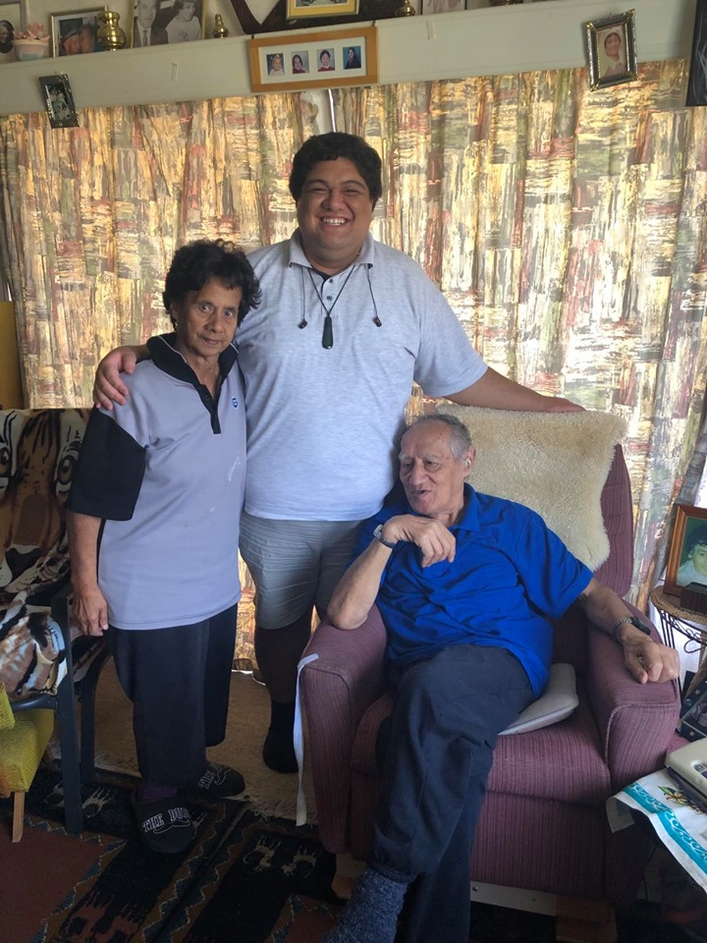
Photo 3: Delayne with Puti and Joe Twoomey at their home in Wanganui.

Back in March, Delayne and Kiri visited founding members Joe and Puti Twoomey at their home in Wanganui. After visiting other members in the area, Delayne and Kiri returned to the Twoomey’s for a wonderful catch up and the best cup of tea they have had in a long time.

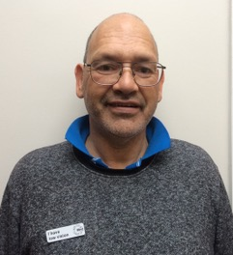
Photo 4: Joseph Knight wearing his new badge.

In May, Kiri worked with Joseph Knight from Christchurch, a new member to Kāpō Māori Aotearoa. Joseph shared a photo of himself wearing his low vision badge proudly – this badge helps his community know that he has low vision.

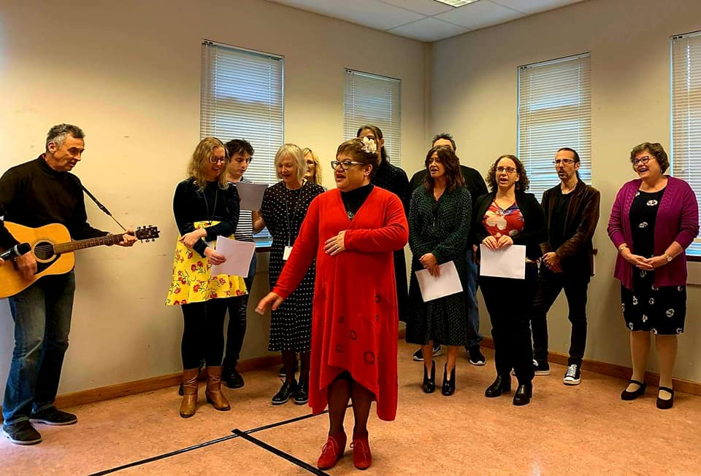
Finally, in June our CEO, Chrissie Cowan was invited to the Blind Low Vision New Zealand launch of their Strategic Plan 2020 – 2024.
Photo 5: Chrissie Cowan leading the waiata at the Blind Low Vision New Zealand Strategic Plan Launch.

Winter/Spring Event 2020 Updates

- RENEWAL OF TANGATA FINANCIAL MEMBERSHIP
Make a difference for Kāpō Māori and their whanau.

Renewals are now open for your 2020 – 2021 Tangata (Financial) Membership by paying the annual fee of $20.

Benefits include:

- Right to elect or be elected to Te Kahui Tumuaki.
- Right to vote at Kāpō Māori Aotearoa General and Special meetings.
- Biennial Conference discounts.
- Kāpō Māori Aotearoa website membership (currently WIP)
- Kāpō Māori Aotearoa memorabilia discounts.

Tangata members have the opportunity to direct their investment into one or all of the 3 kete of knowledge; to enhance the lives of future Kāpō Māori.

- Te Kete Hinengaro (Mind)
The development of tertiary educational grants and development of a research fund to enable the progression of research into supporting our members and their whanau in their communities.
- Te Kete Tinana (Body)
Developing programs and activities that build member confidence and physical capabilities.
- Te Kete Wairua (Soul)
To support member self-awareness through engagement in Te Ao Maori activities.

To renew your membership and invest in the 3 kete of Knowledge please contact the Kapo Maori Aotearoa New Zealand Office
0800 770 990 or info@kapomaori.com

He kokonga whare e kitea; he kokonga ngakau e kore e kitea
The corners of the house are visible; the corners of the heart are invisible

Te Kahui Tumuaki me ngā Kaimahi o Kāpō Māori Aotearoa.

Contact:
0800 770 990
(toll free)
or
www.kapomaori.com
Winter Edition 2020

